Nervous System
The human nervous system consists of:
- the central nervous system (CNS) – the brain and spinal cord
- the peripheral nervous system – nerve cells that carry information to or from the CNS
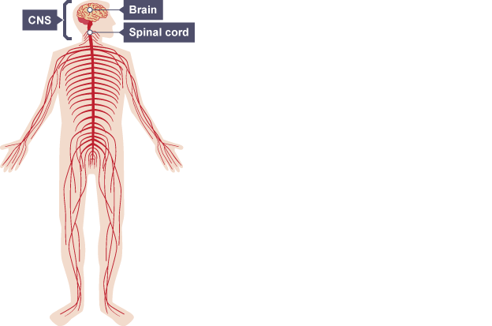
The nervous system composed of nerve cells, or neurones:
Motor Neurone:
- Efferent Neuron – Moving toward a central organ or point
- Relays messages from the brain or spinal cord to the muscles and organs
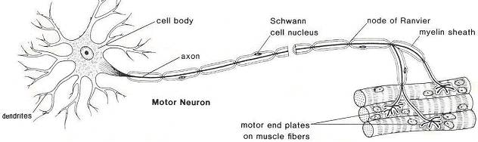

Sensory Neurone:
- Afferent Neuron – Moving away from a central organ or point
- Relays messages from receptors to the brain or spinal cord
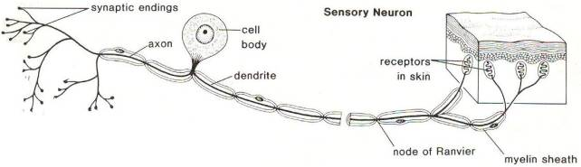

Intermediate (relay neurone):
- Relays message from sensory neurone to motor neurone
- Make up the brain and spinal cord
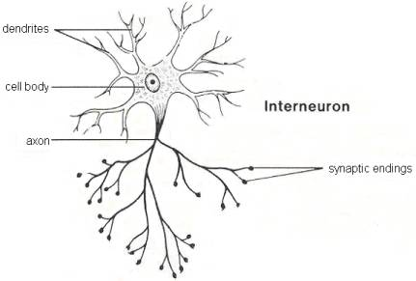

Receptors to effectors
The diagram summarises how information flows from receptors to effectors in the nervous system.
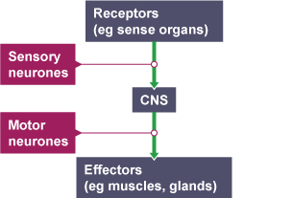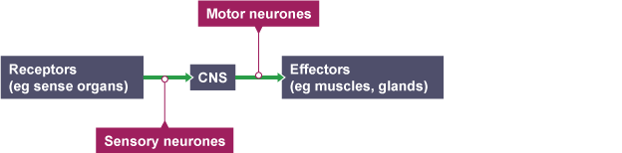

Receptors
Receptors are groups of specialised cells. They can detect a change in the environment (stimulus) and produce electrical impulses in response. Sense organs contain groups of receptors that respond to specific stimuli.
Sense organ | Stimulus
Skin | Touch, temperature
Tongue | Chemicals (in food and drink, for example)
Nose | Chemicals (in the air, for example)
Eye | Light
Ear | Sound

Effectors
Effectors are parts of the body - such as muscles and glands - that produce a response to a detected stimulus. For example:
- a muscle contracting to move an arm
- muscle squeezing saliva from the salivary gland
- a gland releasing a hormone into the blood
This diagram summarises how information flows from receptors to effectors in the nervous system.
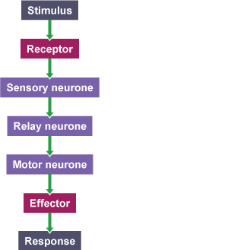

Reflex actions
A reflex action is a way for the body to automatically and rapidly respond to a stimulus to minimise any further damage to the body. It follows this general sequence and does not involve the brain:
stimulus → receptor → sensory neurone → relay neurone → motor neurone → effector → response
The nerve pathway followed by a reflex action is called a reflex arc. For example, a simple reflex arc happens if we accidentally touch something hot.
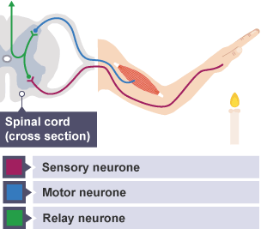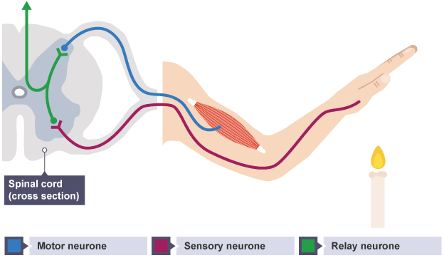
- Receptor in the skin detects a stimulus (the change in temperature).
- Sensory neurone sends impulses to relay neurone.
- Motor neurone sends impulses to effector.
- Effector produces a response (muscle contracts to move hand away).

